Balkan Judo ASSOCIATION
Cadet Balkan Judo Championship 3-4 June 2017 - TEKIRDAG TURKEY
50 KG

ALJOSA CVORO(BIH)
ALJOSA CVORO(BIH)
11 Judoka

LYUBOSLAV GRIGOROV(BUL)

EMİRHAN KARAHAN(TUR) LYUBOSLAV GRIGOROV(BUL)

VIKTOR MOCANU(ROU)

LYUBOSLAV GRIGOROV(BUL)

VIKTOR MOCANU(ROU)

VIKTOR MOCANU(ROU)

VIKTOR MOCANU(ROU)

DJORDJE RADOVIC(SRB) DAVOR VELKOVSKI(MKD)

BERAT BAHADIR(TUR)

DJORDJE RADOVIC(SRB)

BERAT BAHADIR(TUR)

VIKTOR MOCANU(ROMANIA)

BERAT BAHADIR(TUR)

FILIP DJURDJEVAC(MNE) KALANIDIS CHARIS(GRE)

LAZAR ALBIJANIC(SRB)

KALANIDIS CHARIS(GRE)

LAZAR ALBIJANIC(SRB)

ISPAS LORENZO(ROU)

ISPAS LORENZO(ROU)

ISPAS LORENZO(ROU)

ISPAS LORENZO(ROU)

EMİRHAN KARAHAN(TUR) ALJOSA CVORO(BIH)

DJORDJE RADOVIC(SRB)

EMİRHAN KARAHAN(TUR)

DJORDJE RADOVIC(SRB)
- VIKTOR MOCANU(ROMANIA)
- ISPAS LORENZO(ROMANIA)
- BERAT BAHADIR(TURKEY)
3. LYUBOSLAV GRIGOROV(BULGARIA)
5. EMİRHAN KARAHAN(TURKEY)
5. KALANIDIS CHARIS(GREECE)
7. DJORDJE RADOVIC(SERBIA)
7. LAZAR ALBIJANIC(SERBIA)

EMİRHAN KARAHAN(TUR)
BERAT BAHADIR(TURKEY)

BERAT BAHADIR(TUR)

KALANIDIS CHARIS(GRE)

LAZAR ALBIJANIC(SRB)
KALANIDIS CHARIS(GRE)

LAZAR ALBIJANIC(SRB)

KALANIDIS CHARIS(GRE)

LYUBOSLAV GRIGOROV(BUL)

LYUBOSLAV GRIGOROV(BULGARIA)

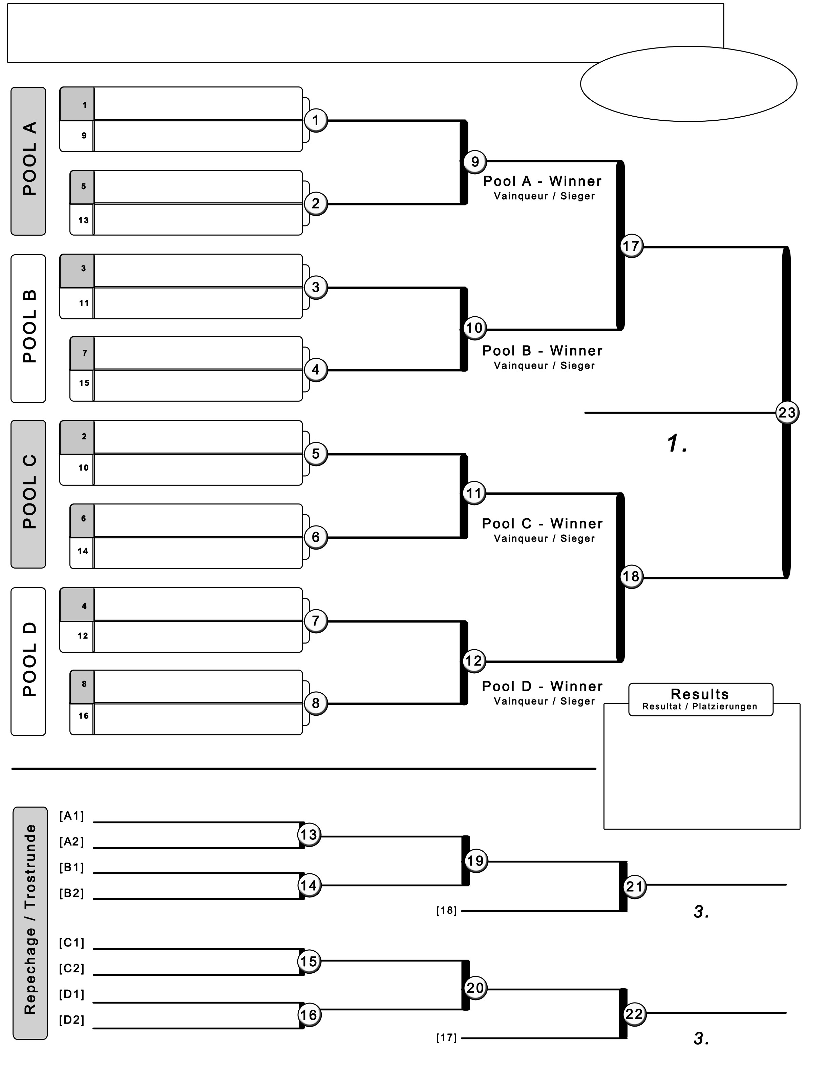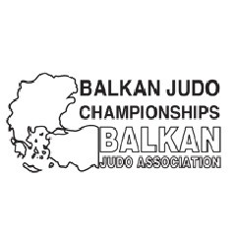

http://www.judo.gov.tr D.Silli - 2017-06-06 11:19:27

Balkan Judo ASSOCIATION
Cadet Balkan Judo Championship 3-4 June 2017 - TEKIRDAG TURKEY
55 KG

DANILO POCUCA(SRB)

IGOR DURICA(BIH)

MATEI TABACARIU(ROU) STEFAN PRELEVIC(MNE)

HRISTO GURTSOV(BUL)

Umut Enes KALKAN(TUR)

STEFANOS POPOUNIDIS(GRE)
DANILO POCUCA(SRB)

MATEI TABACARIU(ROU)

Umut Enes KALKAN(TUR)

STEFANOS POPOUNIDIS(GRE)

MATEI TABACARIU(ROU)

Umut Enes KALKAN(TUR)
15 Judoka

Umut Enes KALKAN(TUR)

REZART HUSENI(MKD)

DEJAN GRUJIC(SRB) EMIL SINANOVIC(MNE)

IONUT BOTOFEI(ROU) ALDON HETEMI(KOS)

GEORGIOS RIZKOV(GRE)

DEJAN GRUJIC(SRB)

IONUT BOTOFEI(ROU)

GEORGIOS RIZKOV(GRE)

Umut Enes KALKAN(TURKEY)

IONUT BOTOFEI(ROU)

GORAN KOZAREV(BUL)

GORAN KOZAREV(BUL)

GORAN KOZAREV(BUL)

GORAN KOZAREV(BUL)

Enes UYSAL(TUR)

STEFAN PRELEVIC(MNE)

DANILO POCUCA(SRB) HRISTO GURTSOV(BUL) STEFANOS POPOUNIDIS(GRE)

DANILO POCUCA(SRB)

HRISTO GURTSOV(BUL)

DANILO POCUCA(SRB)

IONUT BOTOFEI(ROU)

- Umut Enes KALKAN(TURKEY)
- GORAN KOZAREV(BULGARIA)
- IONUT BOTOFEI(ROMANIA)
3. Enes UYSAL(TURKEY)
5. DANILO POCUCA(SERBIA)
5. MATEI TABACARIU(ROMANIA)
7. HRISTO GURTSOV(BULGARIA)
7. DEJAN GRUJIC(SERBIA)

IONUT BOTOFEI(ROMANIA)

ALDON HETEMI(KOS) DEJAN GRUJIC(SRB)
Enes UYSAL(TUR) GEORGIOS RIZKOV(GRE)

DEJAN GRUJIC(SRB)

Enes UYSAL(TUR)

Enes UYSAL(TUR)

MATEI TABACARIU(ROU)

Enes UYSAL(TURKEY)

http://www.judo.gov.tr D.Silli - 2017-06-06 11:19:38

Balkan Judo ASSOCIATION
Cadet Balkan Judo Championship 3-4 June 2017 - TEKIRDAG TURKEY

METIN CAN(ROU)

JAHJA NURKOVIC(MNE) JORDANCHO GJORGIOSKI(MKD)

Salih YILDIZ(TUR)

LAV DIVLJAN(BIH)

METIN CAN(ROU)

JAHJA NURKOVIC(MNE)

Salih YILDIZ(TUR)

LAV DIVLJAN(BIH)

METIN CAN(ROU)

Salih YILDIZ(TUR)
60 KG
17 Judoka

Salih YILDIZ(TUR)

Salih YILDIZ(TUR)

VENDIM RACI(KOS)
VENDIM RACI(KOS)

GEORGIOS MARKOPOULOS(GRE)

GEORGIOS MARKOPOULOS(GRE) GEORGIOS MARKOPOULOS(GRE)

UROS POPOVIC(SRB)

UROS POPOVIC(SRB)

UROS POPOVIC(SRB)

UROS POPOVIC(SRB)

ALEKSANDR GRIGOROV(BUL) ALEKSANDR GRIGOROV(BUL)

VUKASIN TESLA(SRB)

FISNIK HYSENI(KOS)

VUKASIN TESLA(SRB)

FISNIK HYSENI(KOS)

FISNIK HYSENI(KOS)

Salih YILDIZ(TURKEY)

GENADI BURDINYASHKI(BUL)

GENADI BURDINYASHKI(BUL)

FISNIK HYSENI(KOS)

SOFIANIDIS GEORGIOS(GRE)

Abdullah Berkin ÖZCAN(TUR)

IVAN JOZELJIC(BIH)
GENADI BURDINYASHKI(BUL) SOFIANIDIS GEORGIOS(GRE)

Abdullah Berkin ÖZCAN(TUR)
Abdullah Berkin ÖZCAN(TUR)

IVAN JOZELJIC(BIH)

Abdullah Berkin ÖZCAN(TUR)

ROLAND VASIJA(ALB)

BOTOND ANTAL(ROU)

LAV DIVLJAN(BIH)

ROLAND VASIJA(ALB)

BOTOND ANTAL(ROU)

LAV DIVLJAN(BIH) METIN CAN(ROU)

BOTOND ANTAL(ROU)

METIN CAN(ROU)
Abdullah Berkin ÖZCAN(TUR)

- Salih YILDIZ(TURKEY)
- Abdullah Berkin ÖZCAN(TURKEY)
- FISNIK HYSENI(KOSOVO)
3. BOTOND ANTAL(ROMANIA)
5. METIN CAN(ROMANIA)
5. UROS POPOVIC(SERBIA)
7. ALEKSANDR GRIGOROV(BULGARIA)
7. VUKASIN TESLA(SERBIA) METIN CAN(ROU)

ALEKSANDR GRIGOROV(BUL)
ALEKSANDR GRIGOROV(BUL)
ALEKSANDR GRIGOROV(BUL) GEORGIOS MARKOPOULOS(GRE)
FISNIK HYSENI(KOSOVO)

VUKASIN TESLA(SRB)

VUKASIN TESLA(SRB)

VUKASIN TESLA(SRB)
FISNIK HYSENI(KOS)

GENADI BURDINYASHKI(BUL)
IVAN JOZELJIC(BIH)

BOTOND ANTAL(ROU)

IVAN JOZELJIC(BIH)

BOTOND ANTAL(ROU)
BOTOND ANTAL(ROU)

UROS POPOVIC(SRB)
BOTOND ANTAL(ROMANIA)

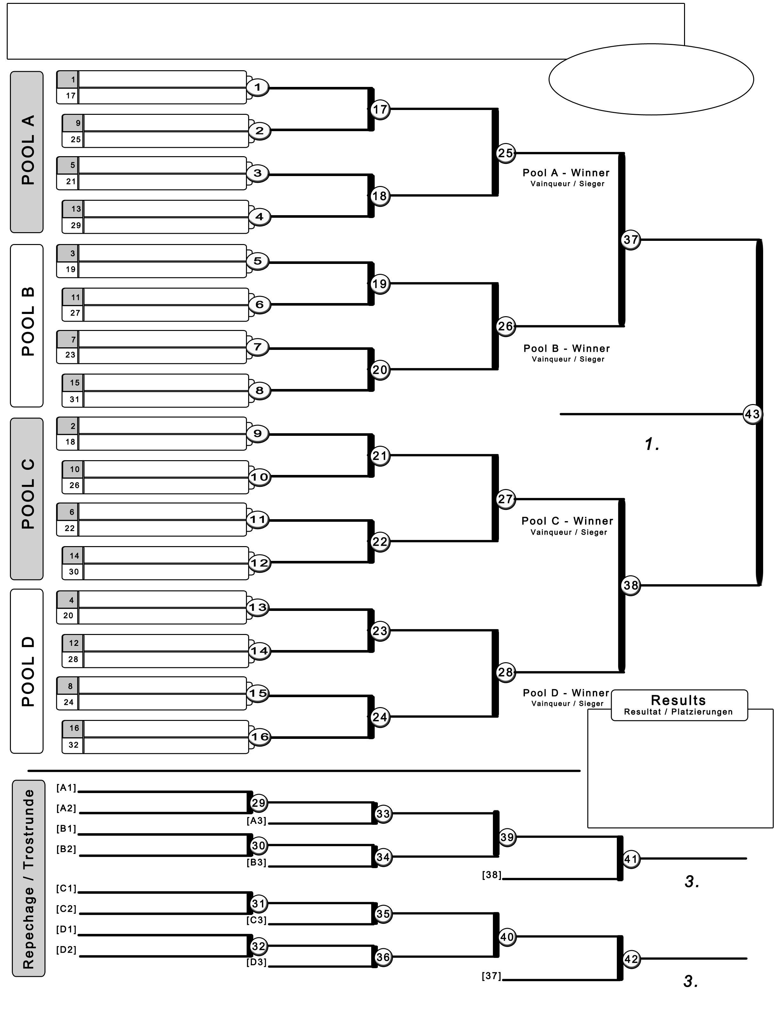

http://www.judo.gov.tr D.Silli - 2017-06-06 11:19:50

Balkan Judo ASSOCIATION
Cadet Balkan Judo Championship 3-4 June 2017 - TEKIRDAG TURKEY
66 KG

GEORGI GRAMATIKOV(BUL)

JOZO ZOVKO(BIH)

MILIJA KRASOJEVIC(SRB) Bayram KANDEMİR(TUR)

ALEXANDRU CHICIN(ROU) VIDOJE GOLUBOVIC(MNE)

VIKTOR GKARAKLIDIS(GRE)
GEORGI GRAMATIKOV(BUL)

Bayram KANDEMİR(TUR)

ALEXANDRU CHICIN(ROU)

VIKTOR GKARAKLIDIS(GRE)

Bayram KANDEMİR(TUR)

ALEXANDRU CHICIN(ROU)
14 Judoka

Bayram KANDEMİR(TUR)

Umalt DEMİREL(TURKEY)

NIKOLA TODOROVIC(SRB) VOJIN TANJEVIC(MNE)

MIROSLAV IVANOV(BUL) Umalt DEMİREL(TUR)

DRAGOS PARASCHIV(ROU)

ATHANASIOS MYLONELLIS(GRE)

NIKOLA TODOROVIC(SRB)

Umalt DEMİREL(TUR)

DRAGOS PARASCHIV(ROU)

HAMZA JASHARI(MKD)

Umalt DEMİREL(TUR)

HAMZA JASHARI(MKD)

Umalt DEMİREL(TUR)

HAMZA JASHARI(MKD)

MILIJA KRASOJEVIC(SRB)
GEORGI GRAMATIKOV(BUL) VIDOJE GOLUBOVIC(MNE)

GEORGI GRAMATIKOV(BUL)

- Umalt DEMİREL(TURKEY)
- Bayram KANDEMİR(TURKEY)
- HAMZA JASHARI(MACEDONIA)
3. NIKOLA TODOROVIC(SERBIA)
5. GEORGI GRAMATIKOV(BULGARIA)
5. ALEXANDRU CHICIN(ROMANIA)
7. VIKTOR GKARAKLIDIS(GREECE)
7. ATHANASIOS MYLONELLIS(GREECE)

GEORGI GRAMATIKOV(BUL)

VIKTOR GKARAKLIDIS(GRE)

MIROSLAV IVANOV(BUL) NIKOLA TODOROVIC(SRB)
ATHANASIOS MYLONELLIS(GRE) DRAGOS PARASCHIV(ROU)
VIKTOR GKARAKLIDIS(GRE)

NIKOLA TODOROVIC(SRB)

ATHANASIOS MYLONELLIS(GRE)

HAMZA JASHARI(MKD)

NIKOLA TODOROVIC(SRB)

ALEXANDRU CHICIN(ROU)
HAMZA JASHARI(MACEDONIA)

NIKOLA TODOROVIC(SERBIA)

http://www.judo.gov.tr D.Silli - 2017-06-06 11:20:00

Balkan Judo ASSOCIATION
Cadet Balkan Judo Championship 3-4 June 2017 - TEKIRDAG TURKEY

VIKTOR VUKOVIC(MNE)

LUIGJ VATAJ(ALB)
EDI SHERIFOVSKI(MKD) SIMON GKARAKLOV(GRE)

RAZVAN BURDUSEL(ROU)

VIKTOR VUKOVIC(MNE)

EDI SHERIFOVSKI(MKD)

SIMON GKARAKLOV(GRE)

RAZVAN BURDUSEL(ROU)

EDI SHERIFOVSKI(MKD)

RAZVAN BURDUSEL(ROU)
73 KG
17 Judoka

RAZVAN BURDUSEL(ROU)

RAZVAN BURDUSEL(ROU)

PETAR PANDZA(SRB)
PETAR PANDZA(SRB)

STOIMENOV JONATHAN(BUL)

STOIMENOV JONATHAN(BUL) STOIMENOV JONATHAN(BUL)

EDIS HUSEINBEGOVIC(BIH)

Mehmet Emin İLHAN(TUR)

ADI PAJA(ALB)

Ahmet Burak ÇUHADAR(TUR)

NIKOLA STANISIC(MNE)

GEORGIOS ZAFIRIDIS(GRE)

JURE ZOVKO(BIH)

DANIEL CIULIFICA(ROU)

EDIS HUSEINBEGOVIC(BIH)

Mehmet Emin İLHAN(TUR)

ADI PAJA(ALB)

Ahmet Burak ÇUHADAR(TUR)

NIKOLA STANISIC(MNE)

GEORGIOS ZAFIRIDIS(GRE)

JURE ZOVKO(BIH)

DANIEL CIULIFICA(ROU)

EDIS HUSEINBEGOVIC(BIH)

Ahmet Burak ÇUHADAR(TUR)

NIKOLA STANISIC(MNE)

DANIEL CIULIFICA(ROU)

STOIMENOV JONATHAN(BUL)

RAZVAN BURDUSEL(ROMANIA)

Ahmet Burak ÇUHADAR(TUR)

MARKO AHMED TRIFUNOVIC(S

MARKO AHMED TRIFUNOVIC(SRB)

MARKO AHMED TRIFUNOVIC(SRB)

ARBER KULLASHI(KOS)

MARKO AHMED TRIFUNOVIC(SRB)

MARKO AHMED TRIFUNOVIC(SRB)

ARBER KULLASHI(KOS)

SIMON GKARAKLOV(GRE)

- RAZVAN BURDUSEL(ROMANIA)
- MARKO AHMED TRIFUNOVIC(SERBIA)
- Ahmet Burak ÇUHADAR(TURKEY)
3. NIKOLA STANISIC(MONTENEGRO)
5. EDI SHERIFOVSKI(MACEDONIA)
5. STOIMENOV JONATHAN(BULGARIA)

SIMON GKARAKLOV(GRE)
EDI SHERIFOVSKI(MKD)
7. EDIS HUSEINBEGOVIC(BOSNIA AND HER

PETAR PANDZA(SRB)

ADI PAJA(ALB)
EDI SHERIFOVSKI(MKD)

PETAR PANDZA(SRB)
EDIS HUSEINBEGOVIC(BIH)

ADI PAJA(ALB)
NIKOLA STANISIC(MNE) ARBER KULLASHI(KOS)

EDIS HUSEINBEGOVIC(BIH)

NIKOLA STANISIC(MNE)
7. DANIEL CIULIFICA(ROMANIA) EDI SHERIFOVSKI(MKD)
Ahmet Burak ÇUHADAR(TURKEY) Ahmet Burak ÇUHADAR(TUR)

NIKOLA STANISIC(MNE)

ARBER KULLASHI(KOS)

DANIEL CIULIFICA(ROU)
DANIEL CIULIFICA(ROU)
NIKOLA STANISIC(MONTENEGRO

STOIMENOV JONATHAN(BUL)

http://www.judo.gov.tr D.Silli - 2017-06-06 11:20:09

Balkan Judo ASSOCIATION
Cadet Balkan Judo Championship 3-4 June 2017 - TEKIRDAG TURKEY
81 KG

JOVAN VULIN(SRB)

VASIL DINEV(BUL)

DANUT PECHEA(ROU)
JOVAN VULIN(SRB)

DANUT PECHEA(ROU)

JOVAN VULIN(SRB)
12 Judoka

Fatih KOSE(TUR)

AMSAL SORLIJA(BIH)

AMSAL SORLIJA(BIH)

Fatih KOSE(TUR)

ANTONIOS POPOV(GRE) Fatih KOSE(TUR)

ALEXANDROS PATINIOTIS(GRE) Mert ŞİŞMANLAR(TUR)

VUK ELEZ(BIH)

Fatih KOSE(TUR)

Mert ŞİŞMANLAR(TUR)

VUK ELEZ(BIH)

VUK ELEZ(BIH)

Fatih KOSE(TURKEY)

KLJAJIC VUKIC(SRB)

KLJAJIC VUKIC(SRB)

KLJAJIC VUKIC(SRB)

KLJAJIC VUKIC(SRB)

KEN UEMURA(ROU)

KEN UEMURA(ROU)

Nenad SINANOVIC(MNE)

VASIL DINEV(BUL)
DANUT PECHEA(ROU) ANTONIOS POPOV(GRE)

VASIL DINEV(BUL)

- Fatih KOSE(TURKEY)
- KLJAJIC VUKIC(SERBIA)
- VUK ELEZ(BOSNIA AND HERZEGOVINA)
3. Mert ŞİŞMANLAR(TURKEY)
5. ANTONIOS POPOV(GREECE)
5. JOVAN VULIN(SERBIA)
7. VASIL DINEV(BULGARIA)
7. KEN UEMURA(ROMANIA)

ANTONIOS POPOV(GRE)

ANTONIOS POPOV(GRE)
VUK ELEZ(BOSNIA AND HERZEGOVINA

AMSAL SORLIJA(BIH)
VUK ELEZ(BIH)

Mert ŞİŞMANLAR(TUR)

KEN UEMURA(ROU)
Mert ŞİŞMANLAR(TUR)

KEN UEMURA(ROU)

Mert ŞİŞMANLAR(TUR)

JOVAN VULIN(SRB)

Mert ŞİŞMANLAR(TURKEY)

http://www.judo.gov.tr D.Silli - 2017-06-06 11:20:17

Balkan Judo ASSOCIATION
Cadet Balkan Judo Championship 3-4 June 2017 - TEKIRDAG TURKEY
90 KG

VOJIN MILICEVIC(SRB)
VOJIN MILICEVIC(SRB)
14 Judoka

SHPAT ZEKA(KOS)

KRISTIYAN ANEV(BUL) SHPAT ZEKA(KOS)

CRISTIAN IONASCIUC(ROU)

Abdullah SOLAKOĞLU(TUR)

IVAN DIVLJAN(BIH)

SHPAT ZEKA(KOS)

Abdullah SOLAKOĞLU(TUR)

IRAKLIS MOISIDIS(GRE)

Abdullah SOLAKOĞLU(TUR)

SHPAT ZEKA(KOS)

IRAKLIS MOISIDIS(GRE)

MILOS MARINKOVIC(SRB)

Mehmet Can TALAY(TUR)

SRDAN SAVIC(BIH) Stefan VIDAKOVIC(MNE)

EDUARD SERBAN(ROU)

ALEXANDROS GKARAKLIDIS(GRE)

BORISLAV VLADOV(BUL)

Mehmet Can TALAY(TUR)

SRDAN SAVIC(BIH)

EDUARD SERBAN(ROU)

BORISLAV VLADOV(BUL)

SHPAT ZEKA(KOSOVO)

Mehmet Can TALAY(TUR)

EDUARD SERBAN(ROU)

EDUARD SERBAN(ROU)

KRISTIYAN ANEV(BUL)
VOJIN MILICEVIC(SRB) CRISTIAN IONASCIUC(ROU) IRAKLIS MOISIDIS(GRE)

VOJIN MILICEVIC(SRB)

CRISTIAN IONASCIUC(ROU)

VOJIN MILICEVIC(SRB)
- SHPAT ZEKA(KOSOVO)
- EDUARD SERBAN(ROMANIA)
- Mehmet Can TALAY(TURKEY)
3. Abdullah SOLAKOĞLU(TURKEY)
5. VOJIN MILICEVIC(SERBIA)
5. ALEXANDROS GKARAKLIDIS(GREECE)
7. CRISTIAN IONASCIUC(ROMANIA)
7. MILOS MARINKOVIC(SERBIA)

Mehmet Can TALAY(TURKEY)

Mehmet Can TALAY(TUR)

MILOS MARINKOVIC(SRB) SRDAN SAVIC(BIH)
ALEXANDROS GKARAKLIDIS(GRE)

MILOS MARINKOVIC(SRB)

ALEXANDROS GKARAKLIDIS(GRE)

BORISLAV VLADOV(BUL)
ALEXANDROS GKARAKLIDIS(GRE)

Abdullah SOLAKOĞLU(TUR)
Abdullah SOLAKOĞLU(TURKEY)

http://www.judo.gov.tr D.Silli - 2017-06-06 11:20:38

Balkan Judo ASSOCIATION
Cadet Balkan Judo Championship 3-4 June 2017 - TEKIRDAG TURKEY
+90 KG

MARKO VASIC(SRB)

Ömer Kemal AYDIN(TUR)

GEORGIOS PAPUTSAKIS(GRE)
Ömer Kemal AYDIN(TUR)

GEORGIOS PAPUTSAKIS(GRE)

Ömer Kemal AYDIN(TUR)
12 Judoka

Ömer Kemal AYDIN(TUR)

IVAYLO DIMITROV(BUL)

IVAYLO DIMITROV(BUL)

IVAYLO DIMITROV(BUL)

Slaven CADJENOVIC(MNE) EDIN MALAGIC(BIH)

ARISTOTELIS LEONIDIS(GRE)

Slaven CADJENOVIC(MNE)

ARISTOTELIS LEONIDIS(GRE)

Ömer Kemal AYDIN(TURKEY)

Hakan AKAR(TUR)

NIKOLA SCEKIC(MNE) Hakan AKAR(TUR)

IVAN DOBREV(BUL)

EDUARD PESCARUS(ROU)

SLOBODAN BAKIC(SRB)

Hakan AKAR(TUR)

EDUARD PESCARUS(ROU)

SLOBODAN BAKIC(SRB)

SLOBODAN BAKIC(SRB)

Hakan AKAR(TUR)

MARKO VASIC(SRB) GEORGIOS PAPUTSAKIS(GRE)

Slaven CADJENOVIC(MNE)

MARKO VASIC(SRB)

Slaven CADJENOVIC(MNE)

MARKO VASIC(SRB)

SLOBODAN BAKIC(SRB)
- Ömer Kemal AYDIN(TURKEY)
- Hakan AKAR(TURKEY)
- MARKO VASIC(SERBIA)
3. EDUARD PESCARUS(ROMANIA)
5. SLOBODAN BAKIC(SERBIA)
5. IVAYLO DIMITROV(BULGARIA)
7. Slaven CADJENOVIC(MONTENEGRO)
7. NIKOLA SCEKIC(MONTENEGRO)

MARKO VASIC(SERBIA)

NIKOLA SCEKIC(MNE) ARISTOTELIS LEONIDIS(GRE)

EDUARD PESCARUS(ROU)

NIKOLA SCEKIC(MNE)

EDUARD PESCARUS(ROU)

EDUARD PESCARUS(ROU)

IVAYLO DIMITROV(BUL)

EDUARD PESCARUS(ROMANIA)

http://www.judo.gov.tr D.Silli - 2017-06-06 11:20:47

Balkan Judo ASSOCIATION
Cadet Balkan Judo Championship 3-4 June 2017 - TEKIRDAG TURKEY
40 KG

ANA MILOSEVIC(SRB)
ANA MILOSEVIC(SRB)
6 Judoka

ANA MILOSEVIC(SRB)

İlknur AŞÇI(TUR)

İlknur AŞÇI(TUR) İlknur AŞÇI(TUR)

İlknur AŞÇI(TUR)

ANA MARIA STROE(ROU) ANA MARIA STROE(ROU)

MÜBERRA GÜNEŞ(TURKEY)

MÜBERRA GÜNEŞ(TUR) MÜBERRA GÜNEŞ(TUR)

MÜBERRA GÜNEŞ(TUR)

ALEKSA GEORGIEVA(BUL) ALEKSA GEORGIEVA(BUL)

MÜBERRA GÜNEŞ(TUR)

ANA BJELIC(SRB) ANA BJELIC(SRB)

ANA BJELIC(SRB)

- MÜBERRA GÜNEŞ(TURKEY)
- İlknur AŞÇI(TURKEY)
- ANA MARIA STROE(ROMANIA)
3. ANA MILOSEVIC(SERBIA)
5. ANA BJELIC(SERBIA)
5. ALEKSA GEORGIEVA(BULGARIA) 7.
7.

ANA MARIA STROE(ROU)

ANA MARIA STROE(ROU) ANA MARIA STROE(ROMANIA)

ANA BJELIC(SRB)

ALEKSA GEORGIEVA(BUL)

ALEKSA GEORGIEVA(BUL)

ANA MILOSEVIC(SERBIA)
ANA MILOSEVIC(SRB)

http://www.judo.gov.tr D.Silli - 2017-06-06 11:17:26

Balkan Judo ASSOCIATION
Cadet Balkan Judo Championship 3-4 June 2017 - TEKIRDAG TURKEY
44 KG

ANA MARIA SIRBU(ROU)
ANA MARIA SIRBU(ROU)
9 Judoka

ERZA MUMINOVIQ(KOS)

ERZA MUMINOVIQ(KOS) TEODORA DIMESKA(MKD)

GAMZE SAYMA(TUR)

ERZA MUMINOVIQ(KOS)

GAMZE SAYMA(TUR)

GAMZE SAYMA(TUR)

GAMZE SAYMA(TUR)

LJUBICA STOJANOVIC(SRB)

LJUBICA STOJANOVIC(SRB)

ÖZGE ANDİÇ(TURKEY)

ÖZGE ANDİÇ(TUR)

ÖZGE ANDİÇ(TUR)

ÖZGE ANDİÇ(TUR)

SLADANA MILIC(MNE)

SLADANA MILIC(MNE)

ÖZGE ANDİÇ(TUR)

ALINA ADRIANA CORBEANU(ROU)

ALINA ADRIANA CORBEANU(ROU)

TEODORA COPIC(SRB)

TEODORA COPIC(SRB)

TEODORA COPIC(SRB)

TEODORA DIMESKA(MKD) ANA MARIA SIRBU(ROU)

LJUBICA STOJANOVIC(SRB)

ANA MARIA SIRBU(ROU)

LJUBICA STOJANOVIC(SRB)

ANA MARIA SIRBU(ROU)

TEODORA COPIC(SRB)
- ÖZGE ANDİÇ(TURKEY)
- GAMZE SAYMA(TURKEY)
- TEODORA COPIC(SERBIA)
3. ERZA MUMINOVIQ(KOSOVO)
5. ANA MARIA SIRBU(ROMANIA)
5. ALINA ADRIANA CORBEANU(ROMANIA)
7. LJUBICA STOJANOVIC(SERBIA)
7. SLADANA MILIC(MONTENEGRO)

TEODORA COPIC(SERBIA)

SLADANA MILIC(MNE)

ALINA ADRIANA CORBEANU(ROU)
SLADANA MILIC(MNE)

ALINA ADRIANA CORBEANU(ROU)

ALINA ADRIANA CORBEANU(ROU)
ERZA MUMINOVIQ(KOSOVO)

ERZA MUMINOVIQ(KOS)

http://www.judo.gov.tr D.Silli - 2017-06-06 11:17:49

Balkan Judo ASSOCIATION
Cadet Balkan Judo Championship 3-4 June 2017 - TEKIRDAG TURKEY
48 KG

MILA PETROVIC(BIH)

ANITA GRUJICIC(MNE)

ANDJELA MLADENOVIC(SRB)
MILA PETROVIC(BIH)

ANDJELA MLADENOVIC(SRB)

ANDJELA MLADENOVIC(SRB)
11 Judoka

ZELİHA CİNCİ(TUR)

ZELİHA CİNCİ(TUR)

ZELİHA CİNCİ(TUR)

ZELİHA CİNCİ(TUR)

CODRUTA FLORENTINA LUNGU(ROU) ARBRESHA REXHEPI(MKD)

BRANISLAVA BJELIC(SRB)

ARBRESHA REXHEPI(MKD)

BRANISLAVA BJELIC(SRB)

ZELİHA CİNCİ(TURKEY)

MARIA VIOLETA DUMITRU(ROU)

MARIA VIOLETA DUMITRU(ROU) GERGANA ILIEVA(BUL)

EMA BRAKNIC(BIH)

MARIA VIOLETA DUMITRU(ROU)

EMA BRAKNIC(BIH)

MARIA VIOLETA DUMITRU(ROU)

Beyza ÖZDEMİR(TUR)

Beyza ÖZDEMİR(TUR)

Beyza ÖZDEMİR(TUR)

- ZELİHA CİNCİ(TURKEY)
- MARIA VIOLETA DUMITRU(ROMANIA)
- Beyza ÖZDEMİR(TURKEY)
3. EMA BRAKNIC(BOSNIA AND HERZEGOVINA)
5. ARBRESHA REXHEPI(MACEDONIA)
5. ANDJELA MLADENOVIC(SERBIA)
7. MILA PETROVIC(BOSNIA AND HERZEGOVIN
7. BRANISLAVA BJELIC(SERBIA)

MILA PETROVIC(BIH)

ARBRESHA REXHEPI(MKD)

GERGANA ILIEVA(BUL) BRANISLAVA BJELIC(SRB)

EMA BRAKNIC(BIH)
MILA PETROVIC(BIH)

ARBRESHA REXHEPI(MKD)

BRANISLAVA BJELIC(SRB)

EMA BRAKNIC(BIH)

ARBRESHA REXHEPI(MKD)

Beyza ÖZDEMİR(TUR)

EMA BRAKNIC(BIH)

ANDJELA MLADENOVIC(SRB)

Beyza ÖZDEMİR(TURKEY)

EMA BRAKNIC(BOSNIA AND HERZEGO

http://www.judo.gov.tr D.Silli - 2017-06-06 11:18:02

Balkan Judo ASSOCIATION
Cadet Balkan Judo Championship 3-4 June 2017 - TEKIRDAG TURKEY
52 KG

FLORENTINA IVANESCU(ROU)

Kübra ŞENYAYLA(TUR)

MAJA BJELICA(BIH) EMILIJA LABOVIC(SRB)

GABRIELA DIMITROVA(BUL)

ANAMARIJA TRAJCHESKA(MKD)
FLORENTINA IVANESCU(ROU)

EMILIJA LABOVIC(SRB)

GABRIELA DIMITROVA(BUL)

ANDJELA POPOVIC(MNE)

FLORENTINA IVANESCU(ROU)

GABRIELA DIMITROVA(BUL)
13 Judoka

FLORENTINA IVANESCU(ROU)

ANDJELA POPOVIC(MNE)

GABRIELA RUSEVA(BUL) CHRISTINA STAMOULI(GRE)

NATALIJA DINOVA(MKD)

CHRISTINA STAMOULI(GRE)

NATALIJA DINOVA(MKD)

FLORENTINA IVANESCU(ROMANIA)

CHRISTINA STAMOULI(GRE)

Rabia SERAS(TUR)

ALEXANDRA PASCA(ROU)

Rabia SERAS(TUR)

ANA MARIJA FRANJIC(BIH)

Rabia SERAS(TUR)

ANA MARIJA FRANJIC(BIH)

Rabia SERAS(TUR)

Kübra ŞENYAYLA(TUR) EMILIJA LABOVIC(SRB)

ANDJELA POPOVIC(MNE)

Kübra ŞENYAYLA(TUR)

ANDJELA POPOVIC(MNE)

Kübra ŞENYAYLA(TUR)
- FLORENTINA IVANESCU(ROMANIA)
- Rabia SERAS(TURKEY)
- Kübra ŞENYAYLA(TURKEY)
3. GABRIELA DIMITROVA(BULGARIA)
5. CHRISTINA STAMOULI(GREECE)
5. ALEXANDRA PASCA(ROMANIA)
7. ANDJELA POPOVIC(MONTENEGRO)
7. GABRIELA RUSEVA(BULGARIA)

Kübra ŞENYAYLA(TURKEY)

CHRISTINA STAMOULI(GRE)

GABRIELA RUSEVA(BUL) NATALIJA DINOVA(MKD)
ALEXANDRA PASCA(ROU) ANA MARIJA FRANJIC(BIH)

GABRIELA RUSEVA(BUL)

ALEXANDRA PASCA(ROU)

ALEXANDRA PASCA(ROU)

GABRIELA DIMITROVA(BUL)

GABRIELA DIMITROVA(BULGARIA)

http://www.judo.gov.tr D.Silli - 2017-06-06 11:18:21

Balkan Judo ASSOCIATION
Cadet Balkan Judo Championship 3-4 June 2017 - TEKIRDAG TURKEY
57 KG

MARIJA DOBRANIC(BIH)

MARIJA TOMESKA(MKD)

ANDJELA POPOVIC(SRB) TEODORA PRELEVIC(MNE)

IULIA AVRAM(ROU) Hasret BOZKURT(TUR)
MARIJA TOMESKA(MKD)

ANDJELA POPOVIC(SRB)

Hasret BOZKURT(TUR)

ANDJELA POPOVIC(SRB)

Hasret BOZKURT(TUR)
14 Judoka

ANDJELA POPOVIC(SRB)

KONSTANTINA THEODORAKOPOULOU(GRE)

KONSTANTINA THEODORAKOPOULOU(GRE)

JELENA TASIC(SERBIA)

ANDREEA BORONTIS(ROU) SELMA LICINA(MNE)

JELENA TASIC(SRB) Dilay TEKİN(TUR)

VALENTINA GKOGKUA(GRE)

YOANNA MANOVA(BUL)

SELMA HAJRO(BIH)

ANDREEA BORONTIS(ROU)

JELENA TASIC(SRB)

YOANNA MANOVA(BUL)

SELMA HAJRO(BIH)

JELENA TASIC(SRB)

SELMA HAJRO(BIH)

JELENA TASIC(SRB)

TEODORA PRELEVIC(MNE)
MARIJA TOMESKA(MKD) IULIA AVRAM(ROU)

TEODORA PRELEVIC(MNE)

IULIA AVRAM(ROU)
- JELENA TASIC(SERBIA)
- ANDJELA POPOVIC(SERBIA)
- SELMA HAJRO(BOSNIA AND HERZEGOVINA
3. Hasret BOZKURT(TURKEY)
5. IULIA AVRAM(ROMANIA)
5. YOANNA MANOVA(BULGARIA)
7. TEODORA PRELEVIC(MONTENEGRO)
7. Dilay TEKİN(TURKEY)

IULIA AVRAM(ROU)
SELMA HAJRO(BOSNIA AND HERZEGO

KONSTANTINA THEODORAKOPOULOU(GRE)
SELMA HAJRO(BIH)

Dilay TEKİN(TUR) ANDREEA BORONTIS(ROU)

YOANNA MANOVA(BUL)

Dilay TEKİN(TUR)

YOANNA MANOVA(BUL)

YOANNA MANOVA(BUL)

Hasret BOZKURT(TUR)

Hasret BOZKURT(TURKEY)

http://www.judo.gov.tr D.Silli - 2017-06-06 11:18:33

Balkan Judo ASSOCIATION
Cadet Balkan Judo Championship 3-4 June 2017 - TEKIRDAG TURKEY
63 KG

ZOI SPYROPOULOU(GRE)

CRINA BIANCA MARTON(ROU)

MILICA CVIJIC(SRB) NADJA VUKICEVIC(MNE)

LIDYA BRANCHEVA(BUL)

MARIJA ZELENIKA(BIH)
CRINA BIANCA MARTON(ROU)

NADJA VUKICEVIC(MNE)

LIDYA BRANCHEVA(BUL)

MARIJA ZELENIKA(BIH)

CRINA BIANCA MARTON(ROU)

MARIJA ZELENIKA(BIH)
13 Judoka

MARIJA ZELENIKA(BIH)

Şeydanur AYDIN(TUR)

HRISTINA SIMIC(SRB)

Ayten Mediha YEKSAN(TUR)

MILKA STAVREVA(BUL)

Ayten Mediha YEKSAN(TUR)

MILKA STAVREVA(BUL)

Ayten Mediha YEKSAN(TURKEY)

Ayten Mediha YEKSAN(TUR)

Ayten Mediha YEKSAN(TUR)

ANDELA SAMARDZIC(BIH)

LAURA FAZLIU(KOS)

MARIANTHI SKORDA(GRE)

LAURA FAZLIU(KOS)

MARIANTHI SKORDA(GRE)

LAURA FAZLIU(KOS)

- Ayten Mediha YEKSAN(TURKEY)
- MARIJA ZELENIKA(BOSNIA AND HERZEGOV
- LAURA FAZLIU(KOSOVO)
3. ANDELA SAMARDZIC(BOSNIA AND HERZEG
5. Şeydanur AYDIN(TURKEY)
5. CRINA BIANCA MARTON(ROMANIA)
7. NADJA VUKICEVIC(MONTENEGRO)

ZOI SPYROPOULOU(GRE)

NADJA VUKICEVIC(MNE)

Şeydanur AYDIN(TUR) LIDYA BRANCHEVA(BUL)

NADJA VUKICEVIC(MNE)

Şeydanur AYDIN(TUR)

Şeydanur AYDIN(TUR)

LAURA FAZLIU(KOS)
7. HRISTINA SIMIC(SERBIA)

LAURA FAZLIU(KOSOVO)

HRISTINA SIMIC(SRB) MILKA STAVREVA(BUL)
ANDELA SAMARDZIC(BIH) MARIANTHI SKORDA(GRE)

HRISTINA SIMIC(SRB)

ANDELA SAMARDZIC(BIH)

ANDELA SAMARDZIC(BIH)

CRINA BIANCA MARTON(ROU)

ANDELA SAMARDZIC(BOSNIA AND HE

http://www.judo.gov.tr D.Silli - 2017-06-06 11:18:45

Balkan Judo ASSOCIATION
Cadet Balkan Judo Championship 3-4 June 2017 - TEKIRDAG TURKEY
70 KG

DIANA MARCU(ROU)
DIANA MARCU(ROU)
8 Judoka

BURCU AKSOY(TUR)

BURCU AKSOY(TUR) BURCU AKSOY(TUR)

ANDJELA LONCAR(SRB)

ANDJELA LONCAR(SRB) ANDJELA LONCAR(SRB)

ANDJELA LONCAR(SRB)

THEOFANIA VASILIOU(GRE) THEOFANIA VASILIOU(GRE)

MERVE TOPOĞLU(TURKEY)

YASMINA PARASCHIV(ROU) YASMINA PARASCHIV(ROU)

MIGLENA RAIKOVA(BUL)

MIGLENA RAIKOVA(BUL) MIGLENA RAIKOVA(BUL)

MERVE TOPOĞLU(TUR)

MILA DJORDJEVIC(SRB) MILA DJORDJEVIC(SRB)

MERVE TOPOĞLU(TUR)

MERVE TOPOĞLU(TUR) MERVE TOPOĞLU(TUR)

DIANA MARCU(ROU)
- MERVE TOPOĞLU(TURKEY)
- ANDJELA LONCAR(SERBIA)
- DIANA MARCU(ROMANIA)
3. BURCU AKSOY(TURKEY)
5. MIGLENA RAIKOVA(BULGARIA)
5. MILA DJORDJEVIC(SERBIA)
7. THEOFANIA VASILIOU(GREECE)
7. YASMINA PARASCHIV(ROMANIA)

DIANA MARCU(ROU)

THEOFANIA VASILIOU(GRE) DIANA MARCU(ROMANIA)

MIGLENA RAIKOVA(BUL)

YASMINA PARASCHIV(ROU)

MILA DJORDJEVIC(SRB)

MILA DJORDJEVIC(SRB)

BURCU AKSOY(TUR)

BURCU AKSOY(TURKEY)

http://www.judo.gov.tr D.Silli - 2017-06-06 11:18:58

Balkan Judo ASSOCIATION
Cadet Balkan Judo Championship 3-4 June 2017 - TEKIRDAG TURKEY
+70 KG

BIANCA SUCIU(ROU)

Meryem KEKLİK(TUR)

NIKOLINA DUBROJA(SRB)
Meryem KEKLİK(TUR)

NIKOLINA DUBROJA(SRB)

Meryem KEKLİK(TUR)
11 Judoka

Meryem KEKLİK(TUR)

MILICA VOJICIC(MNE) MARIA RIZOU(GRE)

JOVANA BABIC(BIH)

MARIA RIZOU(GRE)

JOVANA BABIC(BIH)

MARIA RIZOU(GRE)

Mine KALENDER(TURKEY)

KATARINA ORLOVIC(SRB) Mine KALENDER(TUR)

COSMINA DANILA(ROU)

Mine KALENDER(TUR)

COSMINA DANILA(ROU)

Mine KALENDER(TUR)

Mine KALENDER(TUR)

ANDJEL VUKCEVIC(MNE)

ANDJEL VUKCEVIC(MNE)

HANA PIRALIC(BIH)

HANA PIRALIC(BIH)

HANA PIRALIC(BIH)

- Mine KALENDER(TURKEY)
- Meryem KEKLİK(TURKEY)
- HANA PIRALIC(BOSNIA AND HERZEGOVINA
3. COSMINA DANILA(ROMANIA)
5. NIKOLINA DUBROJA(SERBIA)
5. MARIA RIZOU(GREECE)
7. JOVANA BABIC(BOSNIA AND HERZEGOVINA

BIANCA SUCIU(ROU)
NIKOLINA DUBROJA(SRB) MILICA VOJICIC(MNE)

NIKOLINA DUBROJA(SRB)
7. ANDJEL VUKCEVIC(MONTENEGRO)

NIKOLINA DUBROJA(SRB)

JOVANA BABIC(BIH)
HANA PIRALIC(BOSNIA AND HERZEGO

JOVANA BABIC(BIH)
HANA PIRALIC(BIH)

KATARINA ORLOVIC(SRB) COSMINA DANILA(ROU)

ANDJEL VUKCEVIC(MNE)

COSMINA DANILA(ROU)

ANDJEL VUKCEVIC(MNE)

COSMINA DANILA(ROU)

MARIA RIZOU(GRE)

COSMINA DANILA(ROMANIA)

http://www.judo.gov.tr D.Silli - 2017-06-06 11:19:12

